Steps to create Dynamic Web Project

Step 1: Create a new Dynamic Web Project

1.1. Click on File – New - Other
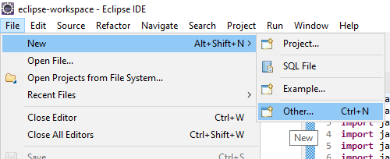
1.2.Search for ‘Dynamic’ and Select ‘Dynamic Web Project’. Then Click on Next

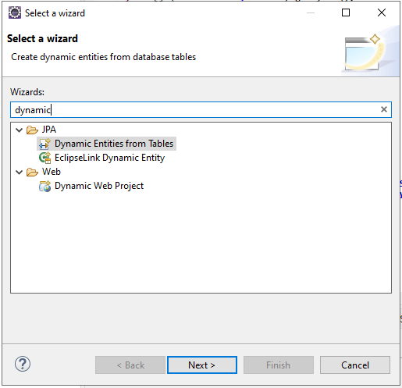

1.3. Enter Project Name of your wish, and click on Finish.

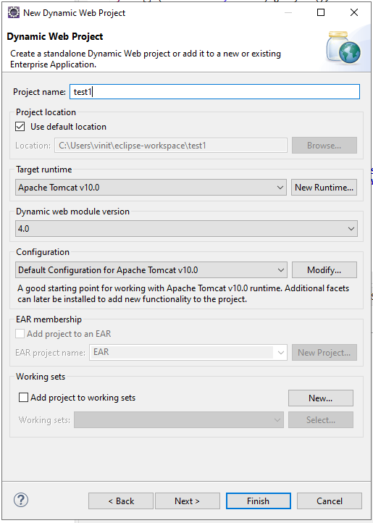

This creates your Dynamic Web project.

Problem Statement 1. Create a Telephone directory using JSP and store all the information within a database, so that later could be retrieved as per the requirement. Make your own assumptions.

Database table (phone1) :

CREATE TABLE phone1
(
id SERIAL PRIMARY KEY,
name varchar(50),
no varchar(50)
);

Index.jsp :

<%@page import="java.sql.*" %>
<%
try
{
String driver ="org.postgresql.Driver";
String url ="jdbc:postgresql://localhost:5432/postgres";
String username ="postgres";
String password ="admin";

Connection con =null;
Class.forName(driver).newInstance();
con = DriverManager.getConnection(url,username,password);
System.out.println("Opened database successfully");

if(request.getParameter("delete")!=null)
{
int id=Integer.parseInt(request.getParameter("delete"));

PreparedStatement pstmt=null; //create statement

pstmt=con.prepareStatement("delete from phone1 where id=? "); // delete query
pstmt.setInt(1,id);
pstmt.executeUpdate(); //execute query

con.close(); //close connection
}
}
catch(Exception e)
{
out.println(e);
}
%>
<html>

<head>

<title>JSP Program to Insert, Update, Delete </title>

</head>

<body>

<br>
<br>
<center>
<h1><a href="add.jsp">CLICK HERE TO ADD A NEW MOBILE NUMBER</a></h1>
</center>
<br>
<center>
<table border='1' cellpadding='23'>
</center>
<tr>
<th>ID</th>
<th>NAME</th>
<th>MOBILE NUMBER</th>
<th>UPDATE</th>
<th>DELETE</th>
</tr>
<%
try
{
String driver ="org.postgresql.Driver";
String url ="jdbc:postgresql://localhost:5432/postgres";
String username ="postgres";
String password ="admin";

Connection con =null;
Class.forName(driver).newInstance();
con = DriverManager.getConnection(url,username,password);

PreparedStatement pstmt=null; //create statement

pstmt=con.prepareStatement("select * from phone1"); //select query

ResultSet rs=pstmt.executeQuery(); //execute query and set in resultset object rs.

while(rs.next())
{
%>
<tr>
<td><%=rs.getInt(1)%></td>
<td><%=rs.getString(2)%></td>
<td><%=rs.getString(3)%></td>
<td><a href="update.jsp?edit=<%=rs.getInt(1)%> ">Edit</a></td>
<td><a href="?delete=<%=rs.getInt(1)%> ">Delete</a></td>

</tr>
<%
}

}
catch(Exception e)
{
out.println(e);
}

%>

</table>

</body>

</html>

Add.jsp :

<%@ page import="java.sql.*" %>

<%
try
{
String driver ="org.postgresql.Driver";
String url ="jdbc:postgresql://localhost:5432/postgres";
String username ="postgres";
String password ="admin";
Connection con =null;
Class.forName(driver).newInstance();
con = DriverManager.getConnection(url,username,password);
System.out.println("Opened database successfully");

if(request.getParameter("btn_add")!=null) //check button click event not null
{
String name,no;
name=request.getParameter("txt_name"); //txt_name
no=request.getParameter("txt_no"); //txt_owner

PreparedStatement pstmt=null; //create statement

pstmt=con.prepareStatement("insert into phone1(name,no)values(?,?)"); // insert query
pstmt.setString(1,name);
pstmt.setString(2,no);
pstmt.executeUpdate(); //execute query
con.close(); //close connection
out.println("Insert Successfully...! Click Home page.");// after insert record successfully message

}

}
catch(Exception e)
{
out.println(e);
}

%>

<html>

<head>

<title>JSP:Insert, Update, Delete using MySQL</title>

<!-- javascript for form validation-->
<script>

function validate()
{
var name = document.myform.txt_name;
var no = document.myform.txt_no;
if (name.value == "")
{
window.alert("please enter a name ?");
name.focus();
return false;
}
if (no.value == "")
{
window.alert("please enter a mobile number ?");
name.focus();
return false;
}

}

</script>
</head>
<body>
<form method="post" name="myform" onsubmit="return validate();">
<center>
<h1>Insert Record</h1>
</center>
<table>
<tr>
<td><b>Name: </b></td>
<td><input type="text" name="txt_name"></td>
</tr>
<tr>
<td><b>Phone number:</b></td></b>
<td><input type="text" name="txt_no"></td>
</tr>
<tr>
<td><input type="submit" name="btn_add" value="Insert"></td>
</tr>
</table>
<center>
<h1><a href="index.jsp">Home page</a></h1>
</center>

</form>

</body>

</html>

Update.jsp :

<%@ page import="java.sql.*" %>

<%
try
{
String driver ="org.postgresql.Driver";
String url ="jdbc:postgresql://localhost:5432/postgres";
String username ="postgres";
String password ="admin";

Connection con =null;
Class.forName(driver).newInstance();
con = DriverManager.getConnection(url,username,password);
System.out.println("Opened database successfully");

if(request.getParameter("btn_update")!=null) //check button click event not null
{
int hide,name,no;;

String name_up,no_up;

hide=Integer.parseInt(request.getParameter("txt_hide")); //it is hidden id get for update record
name_up=request.getParameter("txt_name");
no_up=request.getParameter("txt_no"); //txt_name

PreparedStatement pstmt=null; //create statement

pstmt=con.prepareStatement("update phone1 set name=?,no=? where id=?"); // update query
pstmt.setString(1,name_up);
pstmt.setString(2,no_up);
pstmt.setInt(3,hide);
pstmt.executeUpdate(); //execute query

con.close(); //connection close

out.println("Update Successfully...! Click Back link."); //after update record successfully message
}

}
catch(Exception e)
{
out.println(e);
}

%>

<html>

<head>

<title>JSP:Insert, Update, Delete using MySQL</title>

<!-- javascript for form validation-->
<script>

function validate()
{
var name = document.myform.txt_name;
var no = document.myform.txt_no;

if (rno.value == "")
{
window.alert("please enter name ?");
name.focus();
return false;
}
if (name.value == "")
{
window.alert("please enter number ?");
name.focus();
return false;
}
}

</script>

</head>

<body>

<form method="post" name="myform" onsubmit="return validate();">

<center>
<h1>Update Record</h1>
</center>

<table>
<%
try
{
String driver ="org.postgresql.Driver";
String url ="jdbc:postgresql://localhost:5432/postgres";
String username ="postgres";
String password ="admin";

Connection con =null;
Class.forName(driver).newInstance();
con = DriverManager.getConnection(url,username,password);
System.out.println("Opened database successfully");

if(request.getParameter("edit")!=null)
{
int id=Integer.parseInt(request.getParameter("edit"));

String name,no;

PreparedStatement pstmt=null; // create statement

pstmt=con.prepareStatement("select * from phone1 where id=?"); // sql select query
pstmt.setInt(1,id);
ResultSet rs=pstmt.executeQuery(); // execute query store in resultset object rs.

while(rs.next())
{
id=rs.getInt(1);
name=rs.getString(2);
no=rs.getString(3);

%>
<tr>
<td>Name</td>
<td><input type="text" name="txt_name" value="<%=name%>"></td>
</tr>
<tr>
<td>Mobile Number</td>
<td><input type="text" name="txt_no" value="<%=no%>"></td>
</tr>
<tr>
<td><input type="submit" name="btn_update" value="Update"></td>
</tr>

<input type="hidden" name="txt_hide" value="<%=id%>">
<%
}
}
}
catch(Exception e)
{
out.println(e);
}
%>
</table>

<center>
<h1><a href="index.jsp">Back</a></h1>
</center>

</form>

</body>

</html>

Output:
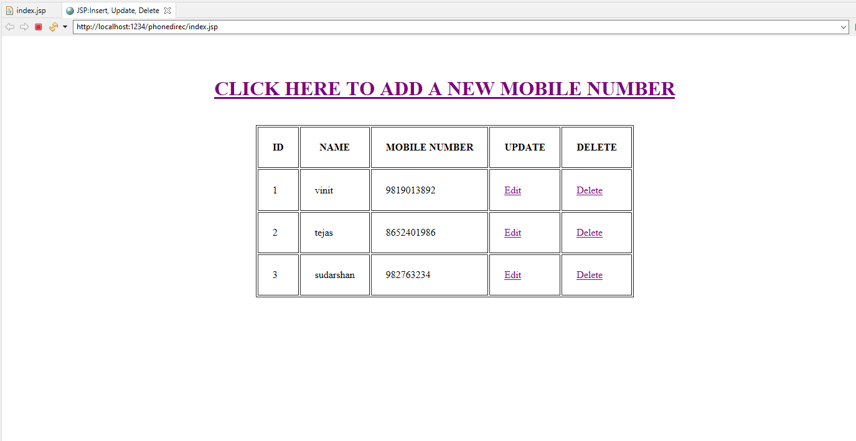
- Adding new record to database
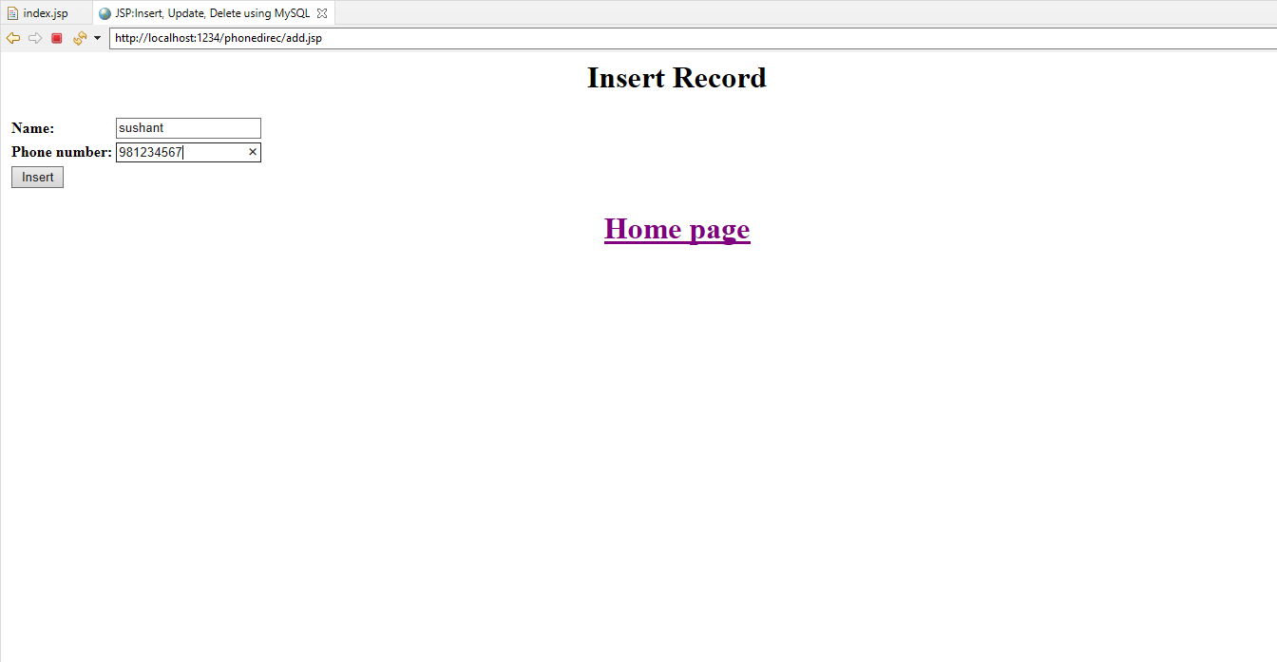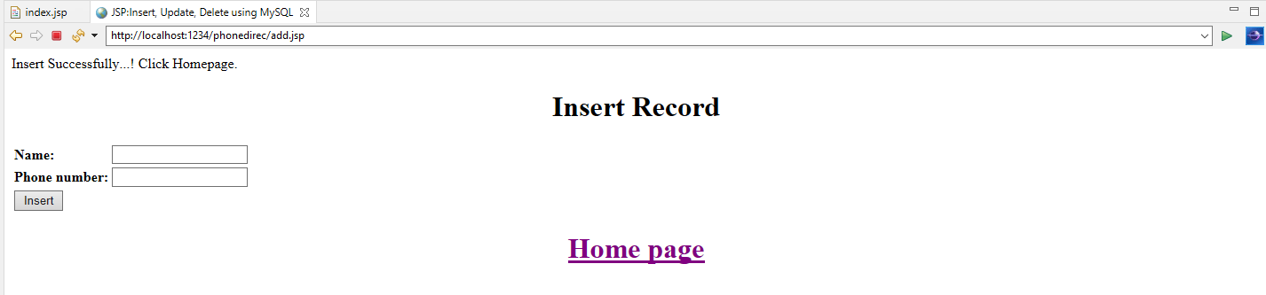
- New record successfully added to the database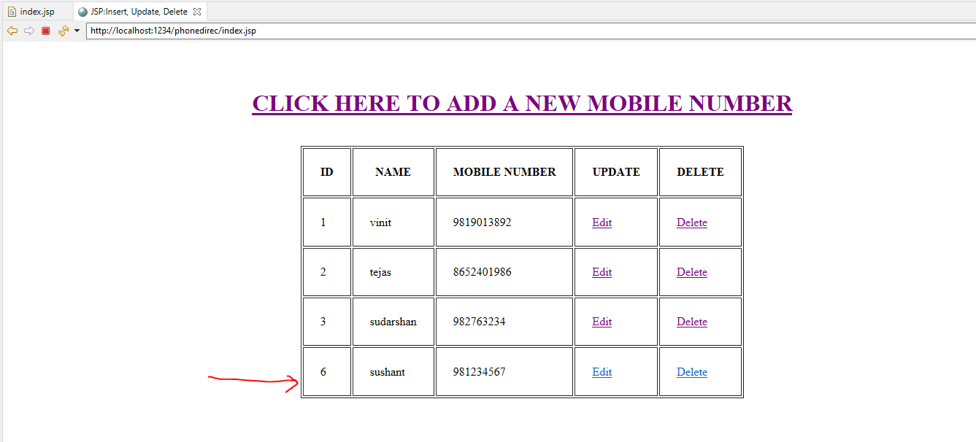

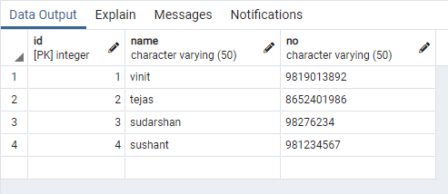
Problem Statement 2. Write a JSP page to display the Registration form (Make your own assumptions)

Database table (studentreg1) :

CREATE TABLE studentreg1
(
id SERIAL PRIMARY KEY,
first_name varchar(50),
last_name varchar(50),
phn_number varchar(20),
address varchar(20),
course varchar(20),
college_name varchar(20)
);

Add.jsp :

<%@ page import="java.sql.*" %>

<%
try
{
String driver ="org.postgresql.Driver";
String url ="jdbc:postgresql://localhost:5432/postgres";
String username ="postgres";
String password ="admin";

Connection con =null;
Class.forName(driver).newInstance();
con = DriverManager.getConnection(url,username,password);
System.out.println("Opened database successfully");

if(request.getParameter("btn_add")!=null) //check button click event not null
{
String first_name,last_name,phn_number,address,course,college_name;
first_name=request.getParameter("txt_first_name"); //txt_name
last_name=request.getParameter("txt_last_name"); //txt_owner
phn_number=request.getParameter("txt_phn_number");
address=request.getParameter("txt_address");
course=request.getParameter("txt_course");
college_name=request.getParameter("txt_college_name");

PreparedStatement pstmt=null; //create statement

pstmt=con.prepareStatement("insert into studentreg1(first_name,last_name,phn_number,address,course,college_name)values(?,?,?,?,?,?)"); // insert query
pstmt.setString(1,first_name);
pstmt.setString(2,last_name);
pstmt.setString(3,phn_number);
pstmt.setString(4,address);
pstmt.setString(5,course);
pstmt.setString(6,college_name);
pstmt.executeUpdate(); //execute query
con.close(); //close connection
out.println("Insert Successfully...!");// after insert record successfully message

}

}
catch(Exception e)
{
out.println(e);
}

%>

<html>

<head>

<!-- javascript for form validation-->
<script>

function validate()
{
var first_name = document.myform.txt_first_name;
var last_name = document.myform.txt_last_name;
var phn_number = document.myform.txt_phn_number;
var address = document.myform.txt_address;
var course = document.myform.txt_course;
var college_name = document.myform.txt_college_name;
if (first_name.value == "")
{
window.alert("please enter a first name ?");
name.focus();
return false;
}
if (last_name.value == "")
{
window.alert("please enter a last name ?");
name.focus();
return false;
}
if (phn_number.value == "")
{
window.alert("please enter a mobile number ?");
name.focus();
return false;
}
if (address.value == "")
{
window.alert("please enter address ?");
name.focus();
return false;
}
if (course.value == "")
{
window.alert("please enter course ?");
name.focus();
return false;
}
if (college_name.value == "")
{
window.alert("please enter college name ?");
name.focus();
return false;
}

}

</script>

</head>

<body bgcolor="deea94">

<div align="center">
<form method="post" name="myform" onsubmit="return validate();">

<center>
<h1><u>STUDENT REGISTRATION FORM</u></h1>
</center>

<br>
<table>
<tr>
<td><b>First Name: </b></td>
<td><input type="text" name="txt_first_name"></td>
</tr>

<tr>
<td><b>Last Name:</b></td></b>
<td><input type="text" name="txt_last_name"></td>
</tr>

<tr>
<td><b>Phone number:</b></td></b>
<td><input type="text" name="txt_phn_number"></td>
</tr>

<tr>
<td><b>Address:</b></td></b>
<td><input type="text" name="txt_address"></td>
</tr>
<tr>
<td><b>Course:</b></td></b>
<td><input type="text" name="txt_course"></td>
</tr>
<tr>
<td><b>College Name:</b></td></b>
<td><input type="text" name="txt_college_name"></td>
</tr>

<tr>
<td><br><input type="submit" name="btn_add" value="Submit"></br></td>
</tr>

</table>

<center>

<p><a><span>&#8595;</span><u>Click Below to list all the</u><span>&#8595;</span></a></p>
<p><a href="index.jsp">Registered Students Details</a></p>
</center>
</form>
</div>
</body>
</html>

Index.jsp :

<%@page import="java.sql.*" %>
<%
try
{
String driver ="org.postgresql.Driver";
String url ="jdbc:postgresql://localhost:5432/postgres";
String username ="postgres";
String password ="admin";

Connection con =null;
Class.forName(driver).newInstance();
con = DriverManager.getConnection(url,username,password);
System.out.println("Opened database successfully");

if(request.getParameter("delete")!=null)
{
int id=Integer.parseInt(request.getParameter("delete"));

PreparedStatement pstmt=null; //create statement

pstmt=con.prepareStatement("delete from studentreg1 where id=? "); // delete query
pstmt.setInt(1,id);
pstmt.executeUpdate(); //execute query

con.close(); //close connection
}
}
catch(Exception e)
{
out.println(e);
}
%>
<html>

<head>
<title>JSP:Insert, Update, Delete </title>
</head>

<body bgcolor="F9CDAD">
<br>
<br>
<br>
<center>
<h1><u>DETAILS OF REGISTERED STUDENTS</u></h1>
</center>
<br><br>
<center>
<table border='1' cellpadding='23'>
</center>
<tr>
<th>ID</th>
<th>First Name</th>
<th>Last Name</th>
<th>Mobile Number</th>
<th>Address</th>
<th>Course</th>
<th>College Name</th>
</tr>
<%
try
{
String driver ="org.postgresql.Driver";
String url ="jdbc:postgresql://localhost:5432/postgres";
String username ="postgres";
String password ="admin";

Connection con =null;
Class.forName(driver).newInstance();
con = DriverManager.getConnection(url,username,password);

PreparedStatement pstmt=null; //create statement

pstmt=con.prepareStatement("select * from studentreg1"); //select query

ResultSet rs=pstmt.executeQuery(); //execute query and set in resultset object rs.

while(rs.next())
{
%>
<tr>
<td><%=rs.getInt(1)%></td>
<td><%=rs.getString(2)%></td>
<td><%=rs.getString(3)%></td>
<td><%=rs.getString(4)%></td>
<td><%=rs.getString(5)%></td>
<td><%=rs.getString(6)%></td>
<td><%=rs.getString(7)%></td>
</tr>
<%
}

}
catch(Exception e)
{
out.println(e);
}
%>
</table>
</body>
</html>

OUTPUT :

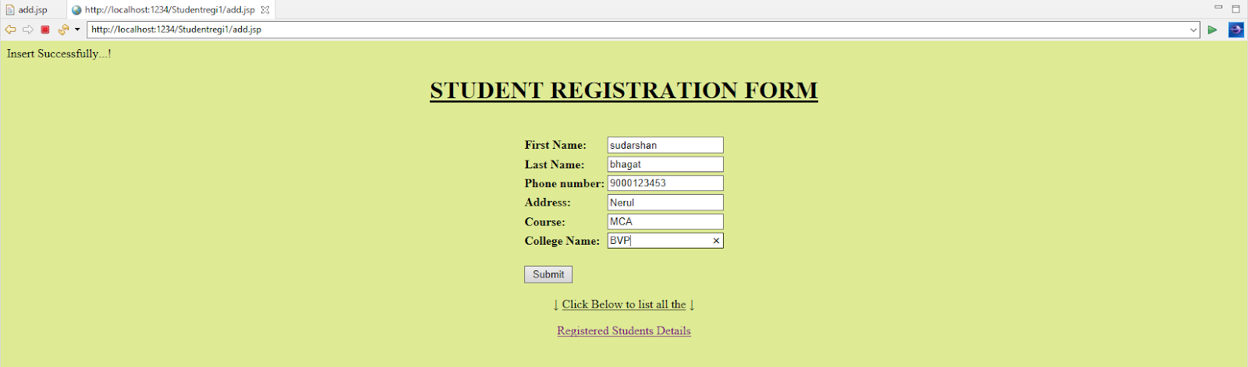
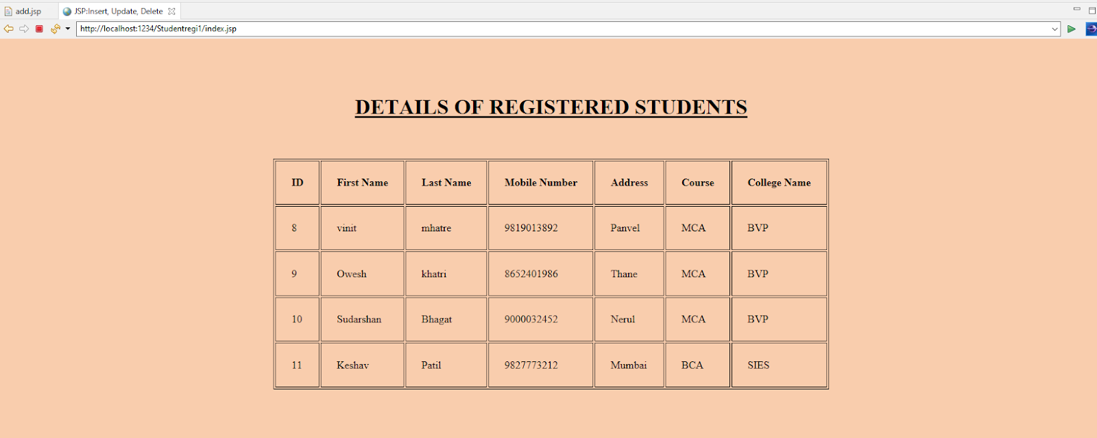
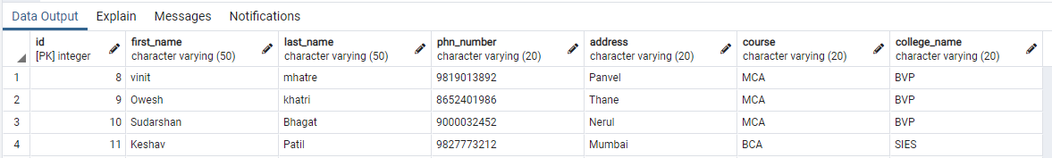

Problem Statement 3.Write a JSP program to add, delete and display the records from StudentMaster (RollNo, Name, Semester, Course) table.

Database table(student1):
CREATE TABLE student1
(
id SERIAL PRIMARY KEY,
rno varchar(50),
name varchar(50),
semester varchar(50),
course varchar(50)
);

Index.jsp :

<%@page import="java.sql.*" %>
<%
try
{
String driver ="org.postgresql.Driver";
String url ="jdbc:postgresql://localhost:5432/postgres";
String username ="postgres";
String password ="admin";
Connection con =null;
Class.forName(driver).newInstance();
con = DriverManager.getConnection(url,username,password);
System.out.println("Opened database successfully");
if(request.getParameter("delete")!=null)
{
int id=Integer.parseInt(request.getParameter("delete"));
PreparedStatement pstmt=null; //create statement
pstmt=con.prepareStatement("delete from student1 where id=? "); // delete query
pstmt.setInt(1,id);
pstmt.executeUpdate(); //execute query
con.close(); //close connection
}
}
catch(Exception e)
{
out.println(e);
}
%>
<html>
<head>
<title>JSP:Insert, Update, Delete </title>
</head>
<body>
<center>
<h1><a href="add.jsp">Add Record</a></h1>
</center>

<table>
<tr>
<th>ID</th>
<th>Roll No</th>
<th>Name</th>
<th>Sem</th>
<th>Course</th>
<th>Update</th>
<th>Delete</th>
</tr>
<%
try
{
String driver ="org.postgresql.Driver";
String url ="jdbc:postgresql://localhost:5432/postgres";
String username ="postgres";
String password ="admin";
Connection con =null;
Class.forName(driver).newInstance();
con = DriverManager.getConnection(url,username,password);
PreparedStatement pstmt=null; //create statement
pstmt=con.prepareStatement("select * from student1"); //select query
ResultSet rs=pstmt.executeQuery(); //execute query and set in resultset object rs.

while(rs.next())
{
%>
<tr>
<td><%=rs.getInt(1)%></td>
<td><%=rs.getString(2)%></td>
<td><%=rs.getString(3)%></td>
<td><%=rs.getString(4)%></td>
<td><%=rs.getString(5)%></td>
<td><a href="update.jsp?edit=<%=rs.getInt(1)%> ">Edit</a></td>
<td><a href="?delete=<%=rs.getInt(1)%> ">Delete</a></td>
</tr>
<%
}
}
catch(Exception e)
{
out.println(e);
}
%>
</table>
</body>
</html>

Add.jsp :

<%@ page import="java.sql.*" %>
<%
try
{
String driver ="org.postgresql.Driver";
String url ="jdbc:postgresql://localhost:5432/postgres";
String username ="postgres";
String password ="admin";
Connection con =null;
Class.forName(driver).newInstance();
con = DriverManager.getConnection(url,username,password);
System.out.println("Opened database successfully");
if(request.getParameter("btn_add")!=null) //check button click event not null
{
String rno,name,semester,course;
rno=request.getParameter("txt_rno");
name=request.getParameter("txt_name"); //txt_name
semester=request.getParameter("txt_sem"); //txt_owner
course=request.getParameter("txt_course"); //txt_owner
PreparedStatement pstmt=null; //create statement
pstmt=con.prepareStatement("insert into student1(rno,name,semester,course)values(?,?,?,?)"); // insert query
pstmt.setString(1,rno);
pstmt.setString(2,name);
pstmt.setString(3,semester);
pstmt.setString(4,course);
pstmt.executeUpdate(); //execute query
con.close(); //close connection
out.println("Insert Successfully...! Click Back link.");// after insert record successfully message
}
}
catch(Exception e)
{
out.println(e);
}
%>
<html>
<head>
<title>JSP:Insert, Update, Delete using MySQL</title>

<!-- javascript for form validation-->
<script>
function validate()
{
var rno = document.myform.txt_rno;
var name = document.myform.txt_name;
var semester = document.myform.txt_sem;
var course = document.myform.txt_course;
if (rno.value == "")
{
window.alert("please enter rno ?");
name.focus();
return false;
}
if (name.value == "")
{
window.alert("please enter name ?");
name.focus();
return false;
}
if (semester.value == "")
{
window.alert("please enter sem ?");
owner.focus();
return false;
}
if (course.value == "")
{
window.alert("please enter course ?");
owner.focus();
return false;
}
}
</script>
</head>
<body>
<form method="post" name="myform" onsubmit="return validate();">
<center>
<h1>Insert Record</h1>
</center>
<table>
<tr>
<td>Roll No</td>
<td><input type="text" name="txt_rno"></td>
</tr>
<tr>
<td>Name</td>
<td><input type="text" name="txt_name"></td>
</tr>
<tr>
<td>Sem</td>
<td><input type="text" name="txt_sem"></td>
</tr>
<tr>
<td>Course</td>
<td><input type="text" name="txt_course"></td>
</tr>
<tr>
<td><input type="submit" name="btn_add" value="Insert"></td>
</tr>
</table>
<center>
<h1><a href="index.jsp">Back</a></h1>
</center>
</form>
</body>
</html>

Update.jsp :
<%@ page import="java.sql.*" %>

<%
try
{
String driver ="org.postgresql.Driver";
String url ="jdbc:postgresql://localhost:5432/postgres";
String username ="postgres";
String password ="admin";
Connection con =null;
Class.forName(driver).newInstance();
con = DriverManager.getConnection(url,username,password);
System.out.println("Opened database successfully");
if(request.getParameter("btn_update")!=null) //check button click event not null
{
int hide,rno,name,semester,course;;
String rno_up,name_up,semester_up,course_up;
hide=Integer.parseInt(request.getParameter("txt_hide")); //it is hidden id get for update record
rno_up=request.getParameter("txt_rno");
name_up=request.getParameter("txt_name"); //txt_name
semester_up=request.getParameter("txt_semester");
course_up=request.getParameter("txt_course");
PreparedStatement pstmt=null; //create statement
pstmt=con.prepareStatement("update student1 set rno=?,name=?, semester=?, course=? where id=?"); // update query
pstmt.setString(1,rno_up);
pstmt.setString(2,name_up);
pstmt.setString(3,semester_up);
pstmt.setString(4,course_up);
pstmt.setInt(5,hide);
pstmt.executeUpdate(); //execute query
con.close(); //connection close
out.println("Update Successfully...! Click Back link."); //after update record successfully message
}
}
catch(Exception e)
{
out.println(e);
}
%>
<html>
<head>
<title>JSP:Insert, Update, Delete using MySQL</title>

<!-- javascript for form validation-->
<script>

function validate()
{
var rno = document.myform.txt_rno;
var name = document.myform.txt_name;
var semester = document.myform.txt_semester;
var course = document.myform.txt_course;
if (rno.value == "")
{
window.alert("please enter rno ?");
name.focus();
return false;
}
if (name.value == "")
{
window.alert("please enter name ?");
name.focus();
return false;
}
if (semester.value == "")
{
window.alert("please enter sem ?");
owner.focus();
return false;
}
if (course.value == "")
{
window.alert("please enter course ?");
owner.focus();
return false;
}}
</script>
</head>
<body>

<form method="post" name="myform" onsubmit="return validate();">
<center>
<h1>Update Record</h1>
</center>
<table>
<%
try
{
String driver ="org.postgresql.Driver";
String url ="jdbc:postgresql://localhost:5432/postgres";
String username ="postgres";
String password ="admin";
Connection con =null;
Class.forName(driver).newInstance();
con = DriverManager.getConnection(url,username,password);
System.out.println("Opened database successfully");
if(request.getParameter("edit")!=null)
{
int id=Integer.parseInt(request.getParameter("edit"));
String rno,name,semester,course;
PreparedStatement pstmt=null; // create statement
pstmt=con.prepareStatement("select * from student1 where id=?"); // sql select query
pstmt.setInt(1,id);
ResultSet rs=pstmt.executeQuery(); // execute query store in resultset object rs.
while(rs.next())
{
id=rs.getInt(1);
rno=rs.getString(2);
name=rs.getString(3);
semester=rs.getString(4);
course=rs.getString(5);
%>
<tr>
<td>Roll NO</td>
<td><input type="text" name="txt_rno" value="<%=rno%>"></td>
</tr>
<tr>
<td>Name</td>
<td><input type="text" name="txt_name" value="<%=name%>"></td>
</tr>
<tr>
<td>Sem</td>
<td><input type="text" name="txt_semester" value="<%=semester%>"></td>
</tr>
<tr>
<td>Course</td>
<td><input type="text" name="txt_course" value="<%=course%>"></td>
</tr>
<tr>
<td><input type="submit" name="btn_update" value="Update"></td>
</tr>
<input type="hidden" name="txt_hide" value="<%=id%>">
<%
}
}
}
catch(Exception e)
{
out.println(e);
}
%>
</table>
<center>
<h1><a href="index.jsp">Back</a></h1>
</center>
</form>
</body></html>

Output:

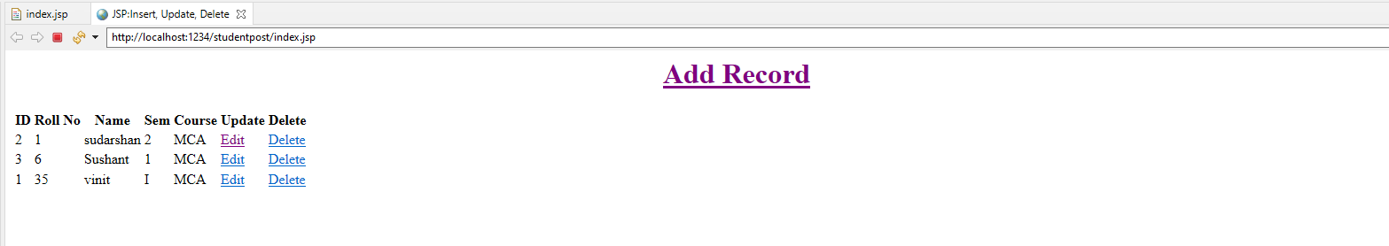

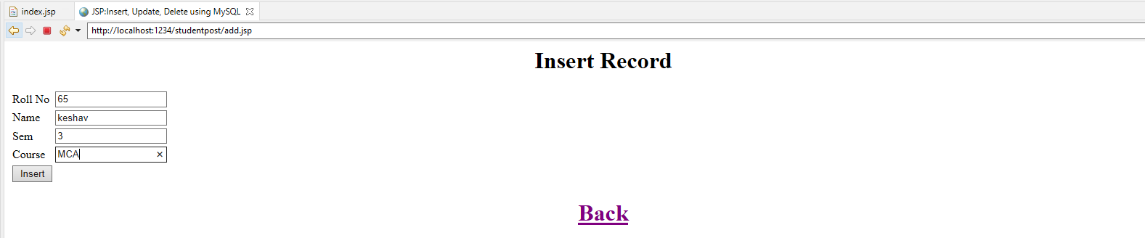
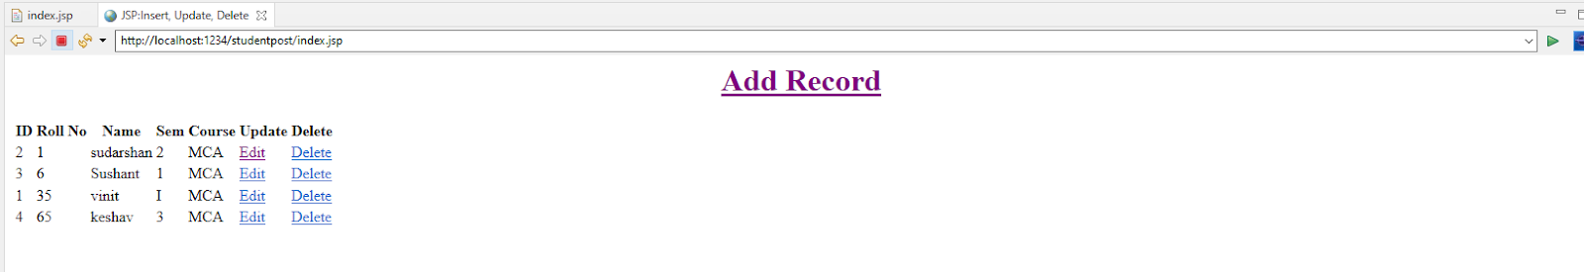
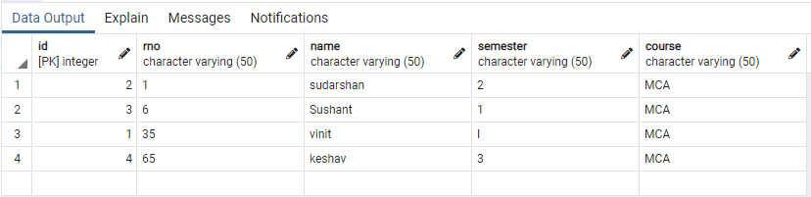

Problem Statement 4. Design loan calculator using JSP which accepts Period of Time (in years) and Principal Loan Amount. Display the payment amount for each loan and then list the loan balance and interest paid for each payment over the term of the loan for the following time period and interest rate:
a. 1 to 7 year at 5.35%
b. 8 to 15 year at 5.5%
c. 16 to 30 year at 5.75%

Cal.jsp :

<%@page contentType="text/html" pageEncoding="UTF-8"%>
<!DOCTYPE HTML PUBLIC "-//W3C//DTD HTML 4.01 Transitional//EN"
"http://www.w3.org/TR/html4/loose.dtd">
<html>
<head>
<meta http-equiv="Content-Type" content="text/html; charset=UTF-8">
<title>JSP Page</title>
</head>
<body><br><br><center>
<form action="test.jsp "><pre>
<h1>Principle :: <input type=text name=principle value=0 " ><br>
No. of Years :: <input type=text name=year value=0 " ><br>
Rate of Interest :: <input type=text name=interest value=0 " > %<br>
<br>
<input type=submit value="Submit"></h1>

</pre></form></center>
</body>
</html>

Test.jsp:

<%@page contentType="text/html" pageEncoding="UTF-8"%>
<!DOCTYPE HTML PUBLIC "-//W3C//DTD HTML 4.01 Transitional//EN"
"http://www.w3.org/TR/html4/loose.dtd">

<html>
<head>
<meta http-equiv="Content-Type" content="text/html; charset=UTF-8">
<title>JSP Page</title>
</head>
<body><br><br><center><pre><H1>
<%

String ns= request.getParameter("principle");
String ns1= request.getParameter("year");
String ns2= request.getParameter("interest");
int n1=Integer.parseInt(ns);
int n2=Integer.parseInt(ns1);
float n3 = Float.valueOf(ns2);

double si=((n1*n2*n3)/100);
double x;
x=n1+si;

double r = (n3)/(12*100);

int mon;
mon=((n2)*12);
double emi= (n1*r*Math.pow(1+r,mon))/(Math.pow(1+r,mon)-1);

%>
<%
out.println("Principle = "+n1);
out.println(" Years = "+n2);
out.println(" Rate of Interest = "+n3);
out.println("<br> ");
out.println("Loan Amount = "+n1);
out.println(" Interest Paid = "+si);
out.println(" Total Loan Amount = "+x);
out.println("<br> ");
out.print(" Loan Tenure in months= " +mon);
out.println("<br> ");
out.print(" EMI is= "+emi+"\n");

%>
</H1>
</pre>
</center>
</body></body>
</html>

Output:

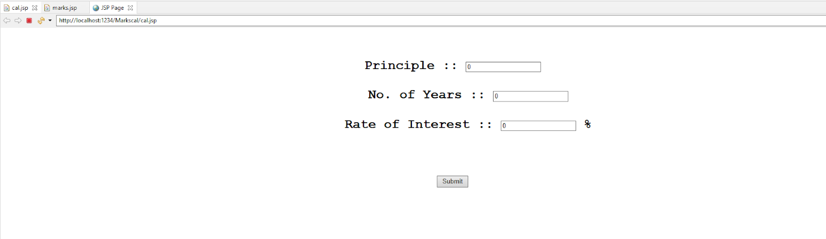

a. 1 to 7 year at 5.35%
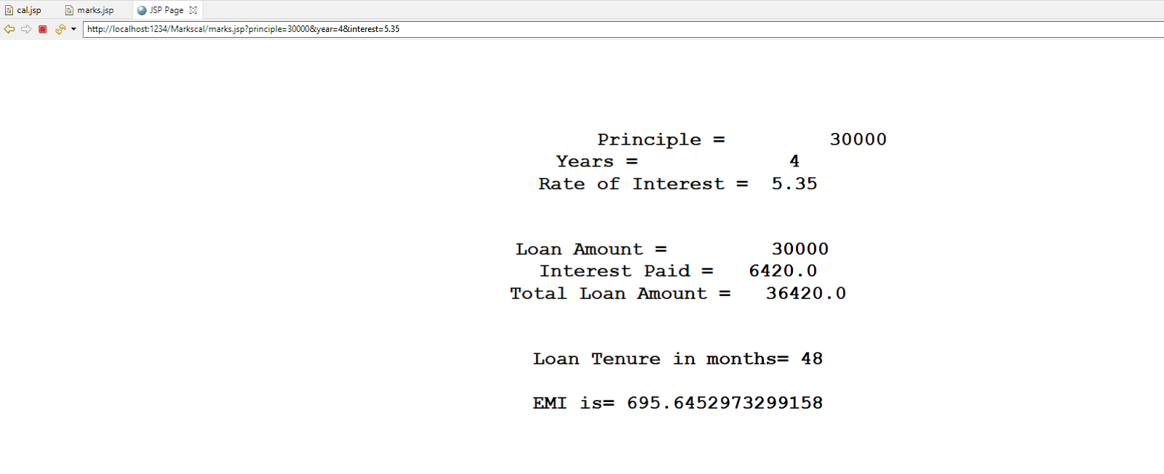

b. 8 to 15 year at 5.5%

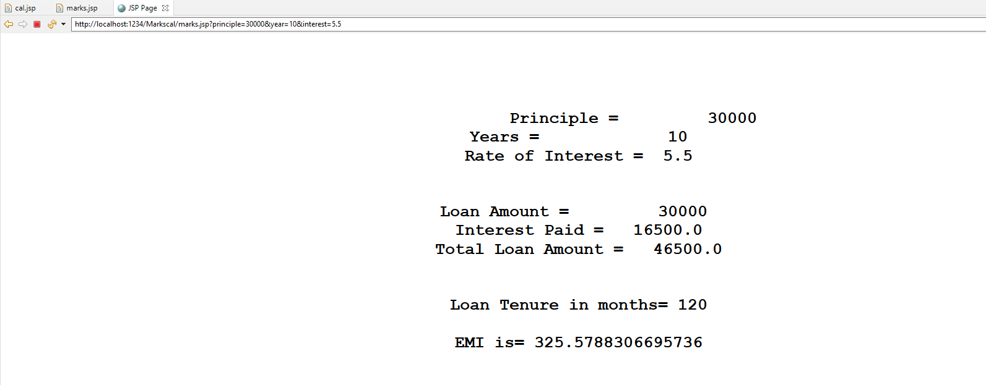

c. 16 to 30 year at 5.75%

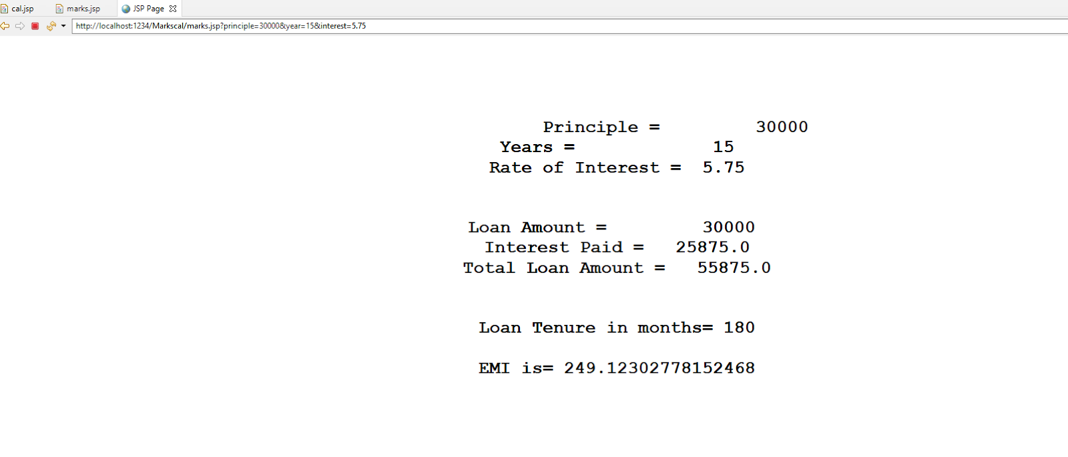

Problem Statement 5. Write a program using JSP that displays a webpage consisting Application form for change of Study Center which can be filled by any student who wants to change his/ her study center. Make necessary assumptions

<%@ page language="java" contentType="text/html; charset=ISO-8859-1"
pageEncoding="ISO-8859-1"%>
<!DOCTYPE html>
<html>
<head>
<meta charset="ISO-8859-1">
<title>Study Center</title>
<link rel="stylesheet" href="https://cdn.jsdelivr.net/npm/bootstrap-icons@1.4.0/font/bootstrap-icons.css">
<link href="https://cdn.jsdelivr.net/npm/bootstrap@5.0.0-beta2/dist/css/bootstrap.min.css" rel="stylesheet" integrity="sha384-BmbxuPwQa2lc/FVzBcNJ7UAyJxM6wuqIj61tLrc4wSX0szH/Ev+nYRRuWlolflfl" crossorigin="anonymous">

</head>
<body>
<center>

<h1>Change of Study Center</h1>

<form action="main.jsp" method="post">

<table>
<tr>
<td>UID No.</td>
<td><input type="text" name="uid" required/></td>
</tr>
<tr>
<td>
Current Center
</td>
<td>
<select name="currentCenter" required>
<option selected disabled hidden></option>
<option value="MUMBAI">MUMBAI</option>
<option value="PUNE">PUNE</option>
<option value="GUJRAT">GUJRAT</option>
</select>
</td>
</tr>
<tr>
<td>
New Center
</td>
<td>
<select name="newCenter" required>
<option selected disabled hidden></option>
<option value="MUMBAI">MUMBAI</option>
<option value="PUNE">PUNE</option>
<option value="GUJRAT">GUJRAT</option>
</select>
</td>
</tr>

</table>
<input type="submit" value="Submit"/>
</form>

</center>

<%

if(request.getParameter("uid") != null&& request.getParameter("currentCenter") != null&& request.getParameter("newCenter") != null){
out.println("<center><br>Your request to change Study Center from <br>" +
request.getParameter("currentCenter") + " to " + request.getParameter("newCenter") + "<br> has been sent to the Administrator.</center>");
}

%>

</body>
</html>

Output:

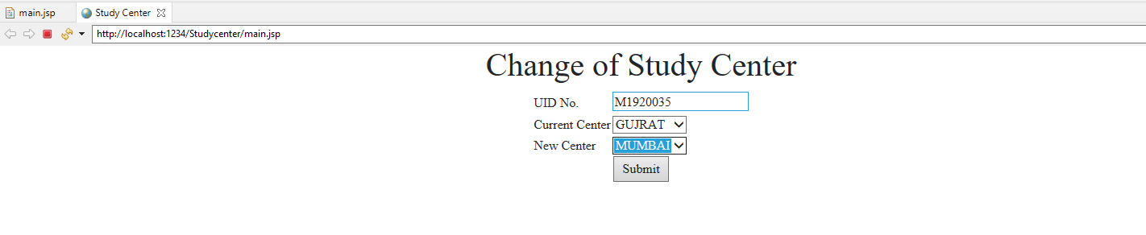

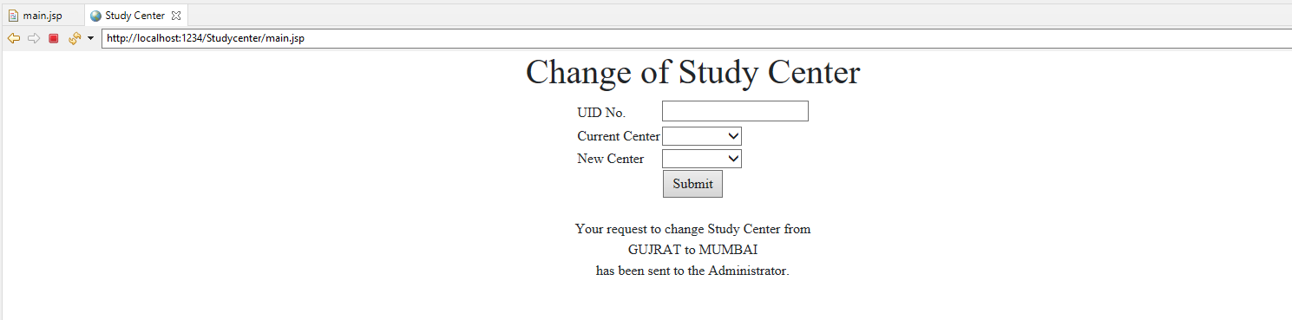

Problem Statement 6. Write a JSP program that demonstrates the use of JSP declaration, scriptlet, directives, expression, header and footer.

Main.jsp :

<%@ page language="java" contentType="text/html; charset=ISO-8859-1"
pageEncoding="ISO-8859-1"%>
<!DOCTYPE html>
<html>
<head>
<meta charset="ISO-8859-1">
<title>JSP EXAMPLE</title>
</head>
<body>
<%@ include file = "header.jsp" %>
<center>
<%! int data=50; %>
<%= "Value of the variable is:"+data %>
<%!
double circle(int n){ return 3.14*n*n;}
%></br>
<%= "Area of circle is:"+ circle(3) %></br>
<%!
int rectangle(int l,int b){ return l*b;}
%>
<%= "Area of rectangle is:"+rectangle(3,4
) %></br>
<%!
int perimeter(int x,int y){
int peri=2*(x+y);
return peri;}
%>
<%= "Perimeter of rectanlge:"+perimeter(5,6
) %></br>
<p>Thanks for visiting my page.</p>
</center>
<%@ include file = "footer.jsp" %>
</body>
</html>

Header.jsp :

<%@ page language="java" contentType="text/html; charset=ISO-8859-1"
pageEncoding="ISO-8859-1"%>
<!DOCTYPE html>

<%!
int pageCount = 0;
void addCount() {
pageCount++;
}
%>
<% addCount(); %>
<html>
<head>
<title>JSP declaration, scriptlet, directives, expression, header and footer Example</title>
</head>
<body>
<center>
<h2><u>The include Directive Example</u></h2>
<p><b>This site has been visited <%= pageCount %> times.</b></p>
</center>
<br/><br/>

</body>
</html>

Footer.jsp:

<%@ page language="java" contentType="text/html; charset=ISO-8859-1"
pageEncoding="ISO-8859-1"%>
<!DOCTYPE html>
<html>
<head>
<meta charset="ISO-8859-1">
<title>Insert title here</title>
</head>
<body>
<br/><br/>
<center><p><b>Vinit Mhatre 35</b></p></center></body></html>
Output:

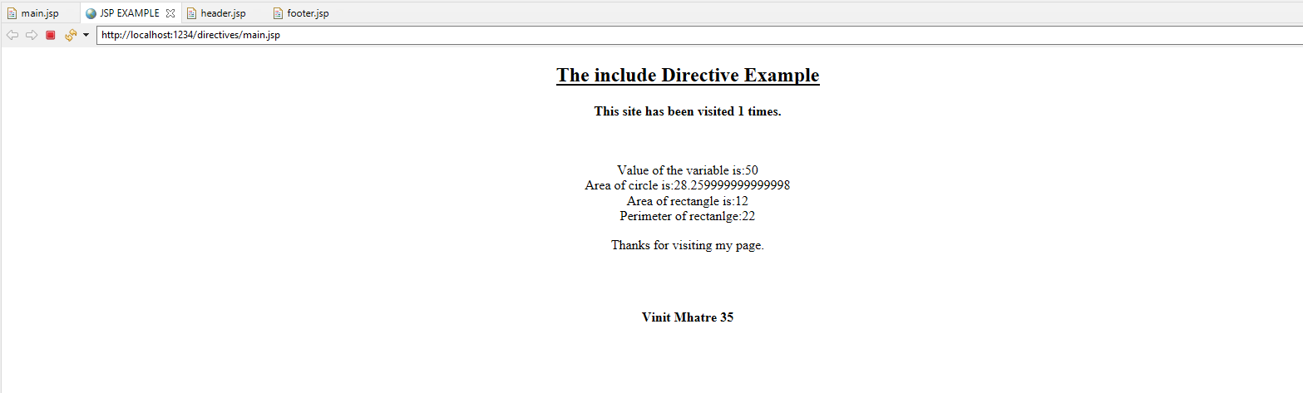

Problem Statement 7. Write a JSP program that demonstrates the use of session or cookies.

Cookie.jsp :

<%@ page language="java" contentType="text/html; charset=ISO-8859-1"
pageEncoding="ISO-8859-1"%>
<!DOCTYPE html PUBLIC "-//W3C//DTD HTML 4.01 Transitional//EN" "http://www.w3.org/TR/html4/loose.dtd">
<html>
<head>
<meta http-equiv="Content-Type" content="text/html; charset=ISO-8859-1">
<title>Cookie</title>
</head>
<body><center>
<br><br><br><br><br>
<form action="action.jsp" method="GET">
<h1>Program that demonstrates the use of session or cookies.</h1>
Username: <input type="text" name="username">
<br><br>
Email: <input type="text" name="email" />
<br><br>
<input type="submit" value="Submit" />
</center>
</form>
</body>
</html>

Action.jsp :

<%@ page language="java" contentType="text/html; charset=ISO-8859-1"
pageEncoding="ISO-8859-1"%>
<!DOCTYPE html PUBLIC "-//W3C//DTD HTML 4.01 Transitional//EN" "http://www.w3.org/TR/html4/loose.dtd">
<%

Cookie username = new Cookie("username",
request.getParameter("username"));
Cookie email = new Cookie("email",
request.getParameter("email"));

username.setMaxAge(60*60*10);
email.setMaxAge(60*60*10);

// Add both the cookies in the response header.
response.addCookie( username );
response.addCookie( email );
%>

<html>
<head>
<meta http-equiv="Content-Type" content="text/html; charset=ISO-8859-1">
<title>Cookie JSP</title>
</head>
<body>
<br><br><br><br><br><br><br><br><br><br><br><br><br><br><br><br>
<center>
<b>Username:</b>
<%= request.getParameter("username")%><br><br>
<b>Email:</b>
<%= request.getParameter("email")%>
</center>
</body>
</html>

Output:

